Hello professor this my answer for Homework 1

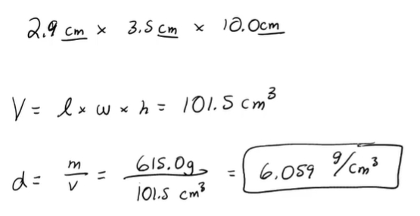

Student ID : 201923250

Name : Kobilov Ilkhomjon